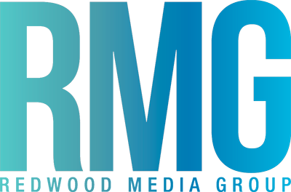

FOR IMMEDIATE RELEASE
Media Contact:
Jaclyn Acree
Olive PR Solutions, Inc.
m. 408-761-8958 o. 619-955-5285
jaclyn@oliveprsolutions.com

Redwood Media Group Acquires Art Santa Fe
- Art Santa Fe Added To Redwood Media Group’s Roster
Effective December 15, 2015 -

HINCKLEY, OHIO (December 21, 2015) – Redwood Media Group, which owns and produces fine art show exhibitions including Spectrum Miami, Artexpo New York, Art San Diego, and Spectrum Indian Wells, today announced the acquisition of Art Santa Fe, an international contemporary art fair.

“Art Santa Fe is a great additions to our growing portfolio of fine art shows and we’re proud to add them to the Redwood Media Group lineup,” said Eric Smith, president of Redwood Media Group. “With the growth of art fairs in the U.S. and worldwide, Redwood Media Group is poised to support this growth as gallerists—representing both career and emerging artists—are realizing their potential in exhibiting at art shows.”

Redwood Media Group will provide additional operational, marketing, and promotional support to the show, bringing it to national and international acclaim. The show will now have the benefit of having an entire team that includes marketing, business development, exhibitor relations, and media communications, to help take it to the next level.

“After 15 successful years of producing Art Santa Fe, I believed that the fair would benefit from being part of a family of fairs. Its acquisition by Redwood Media Group accomplishes that goal,” said Charlotte Jackson, former owner and director of Art Santa Fe. “With Redwood Media Group’s experience and expertise, I know the show will continue to build and grow its importance in the Santa Fe art market.”

Art Santa Fe will celebrate 16 years next summer, taking place from July 7–10, 2016. The show is an internationally recognized art fair offering an overview of contemporary and modern art from the finest galleries in Europe, Asia, South America, and North America. Santa Fe claims the second largest art market in the United States and draws visitors from across the country and internationally. With years of experience, Art Santa Fe remains unique in the art world, offering art buyers an opportunity that goes beyond the fair's doors.

More information on additions and changes that will be made to the show will be announced soon.

###

About Redwood Media Group
Redwood Media Group (RMG) has a long history serving the global fine art community. The company’s full suite of fine art services includes fine art exhibitions, art business education, fine art publications, fine art mentoring, marketing and social media, and more. Redwood owns and produces fine art shows and conferences including Artexpo New York, Art San Diego, Spectrum Indian Wells, Spectrum Miami, and [SOLO] New York. The company also owns and publishes Art Business News magazine and DECOR magazine. For more information, visit: www.artbusinessnews.com, www.decormagazine.com, www.artexponewyork.com, www.artexponewyork.com/solo, www.art-sandiego.com, www.spectrum-miami.com, and www.spectrum-indianwells.com.

